NGAME is an instance of a nearly stateless machine. This claim distinguishes NGAME from other anomaly detection tools. “Stateless” means that from one step to the next through its pipeline and from one day’s execution to the next, NGAME is not required to retain the history of each day’s transactions. This characteristic alone distinguishes NGAME from the Audit Log in QuickBooks. The company relies on the Audit Log for details reaching back in time. I.E. The Audit Log is longitudinal; NGAME is not. NGAME’s advantage as a stateless machine is that it can be deployed on a computer with only a modest amount of storage and (2) it will not require ever more storage over its use.

On the other hand, NGAME creates, curates and bases its reporting on a historical (longitudinal) record, a spreadsheet, referred to as “matrix”:
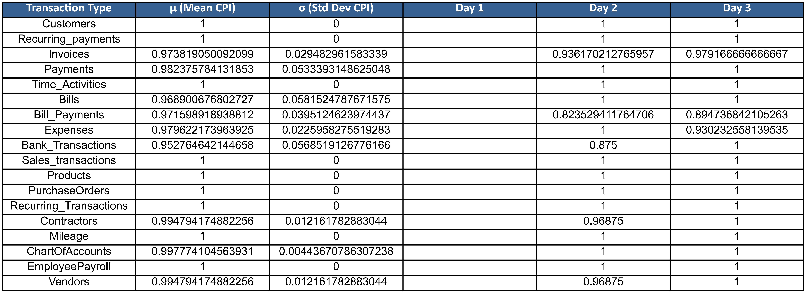
This discussion aims to clarify—here in non-technical language—the statistical expressions that generate NGAME’s reporting to the FRP. All of those expressions are based this matrix.

The source (“ground truth”) of the numbers in the matrix consists of a set of ontologies: quickbooks_ontology_Yesterday.ttl and quickbooks_ontology_Today.ttl. These are snapshots that capture extensive details of 18 types of transations—from yesterday and from today. Each of those data are endpoints that Intuit provides in their application programmer’s interface (API), exposing those data to NGAME. These two compact ontology files (178K each) plus the small-and-slowly-expanding matrix (starting at only 12K) are the only data retained from one day to the next.

This section describes each element of the statistical measures underlying NGAME. Those measures refer to the human-readable captions in the matrix: “Transaction Type,” “mu(Main CPI),” sigma(Std Dev CPI), and “Day 1, Day 2,...”. “CPI” is the Churn Persistence Index, the core driver of NGAME’s workflow.

Transaction Types

NGAME bases its calculations on 18 transaction types that appear in column A: “Customers” is Transaction Type(1), “Bill Payments” is Transaction Type (8), and so on. Note that the sequence numbers of the transactions (1-18) are not the row numbers of the spreadsheet. In the spreadsheet, row 1 of Column A contains the text “Transaction Type.”

This study relies on Jaccard similarity, the best-fitting statistical measure for comparing the state of today’s ledger with that of yesterday. The study refers to the numerical calculation of difference found in that comparison as today’s churn.The 30-day training period yields a more-encompassing calculation to establish the typical churn for the organization. Comparing today’s churn with the organization’s typical churn allows the engine then to detect anomalous behavior.

Ledger Status

Jaccard measurement for NGAME assumes that QBO provides a URI that references the proper ledger. Moreover, it relies on a full and faithful snapshot of all of the entries in the ledger for all 18 transaction types. In NGAME, the Data Extraction Agent discovers all of the transactions for all of the ledger’s transaction types, then creates an ontology file (.ttl) that serves as the “full and faithful snapshot” of the ledger, both for today and yesterday. The Jaccard calculation (and the explanation below) references today’s and yesterday’s snapshots as “T” and “Y”

Daily Set-up (informal description)

Jaccard must read transaction data from both T and Y. It must do so for every one of the 18 transaction types. Here “k” stands for “each transaction type.” For each k, NGAME’s CPI Analyst Agent queries the day-to-day difference to count occurrences of the following cases:
- How many of this k were present in all of Y and all of T?
- How many of this k were present in all of Y only (i.e. did it get removed today?)
- How many of this k were present in all of T only (i.e. did it get added today?)
- What’s the total number n of all of the occurrences of k above?

The formal representation of each query and each resulting count is as follows:

Query | Result
​​​|𝑌𝑘 ∩ 𝑇𝑘| | 𝑎𝑘
|𝑌𝑘 ∖ 𝑇𝑘| | 𝑏𝑘
|𝑇𝑘 ∖ 𝑌𝑘| | 𝑐𝑘
𝑎𝑘 + 𝑏𝑘 + 𝑐𝑘 | 𝑛𝑘

